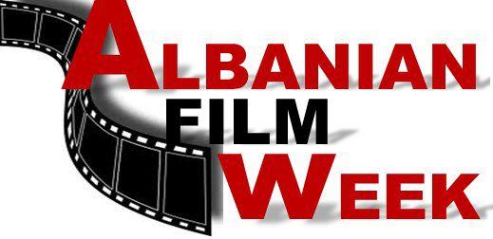
Albanian Film Week in New York 2014
3rd Edition

The Albanian Film Week in New York is the first of its kind; United States is one of the countries with highest number of Albanians, active in promotion of Albanian art and culture who in the last two years have welcomed this event as one major cultural step.
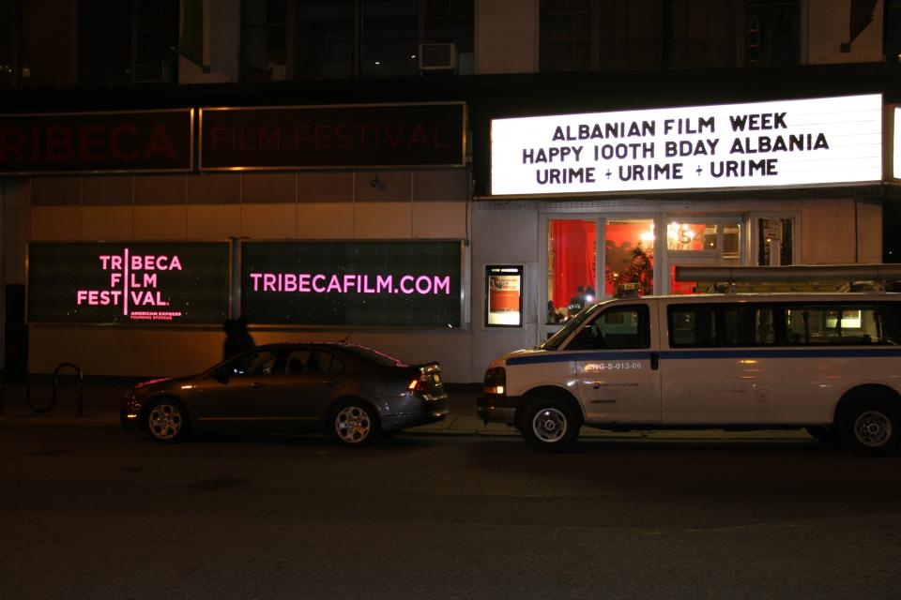
(Tribeca Cinema entrance, where the first Edition of Albanian Film Week took place)

July 2014

Background

First Albanian Week in United States was ideated and founded by Mrika Krasniqi, producer and film director.

First Edition of Albanian Film Week in New York was held for the first time on 05th of November through 11th of November, 2012 with the slogan “100 for 100”, where 100 movies of Albanian cinematography were presented in honour of 100th Albanian Independence anniversary.
Many eminent Albanian – American personalities, diplomats designated to Albanian and Kosovo Embassies in NY and many representatives of Albanian community living in New York have attended the event.
First Edition of Albanian Film week was organised in three known American theatres: Tribeca Cinemas (54 Varic str. NYC 10013), Producers Club Theatre (358 west 44th str. 10036) and Lehman College/Bronxnet (2790 Goulden Av. Carmen Hall NY 10468).

Promo AFW 2012
http://www.youtube.com/watch?v=qTtrQjMlLTo&feature=youtu.be

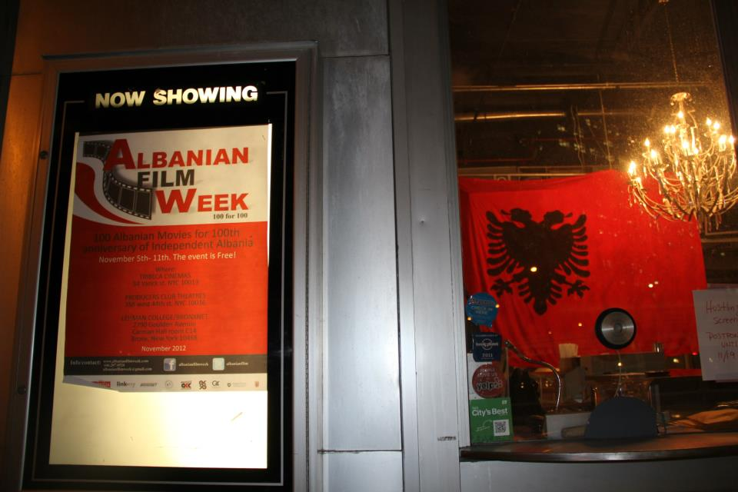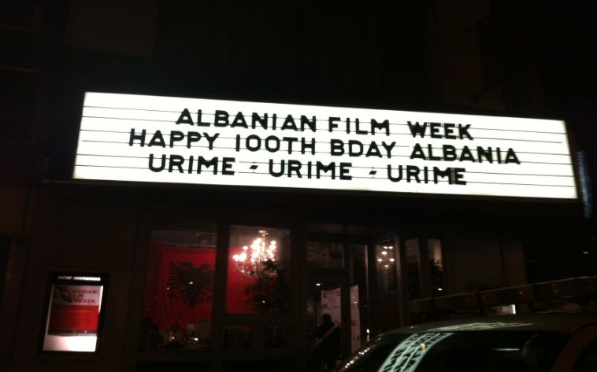(Images form 1st Edition of Albanian Film Week in New York 2012)
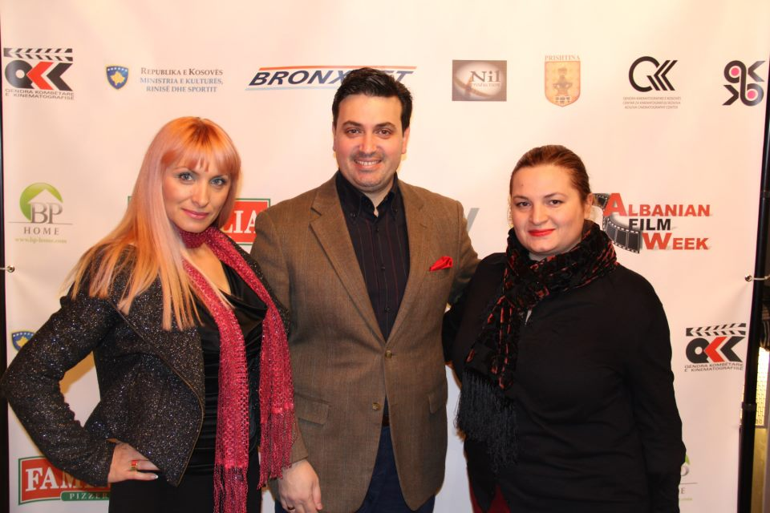 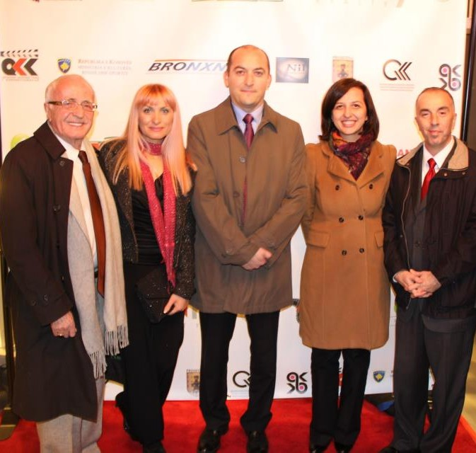 (Albanian Embassy Attaché in NY) (Albanian Embassy Attaché in NY)
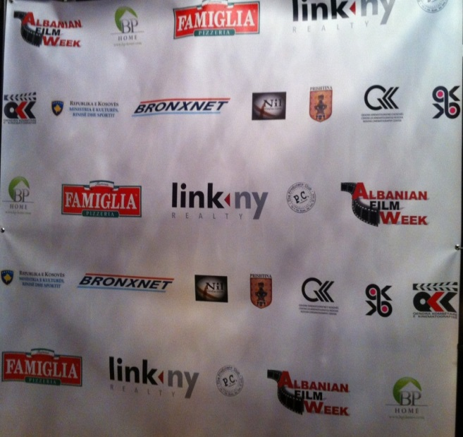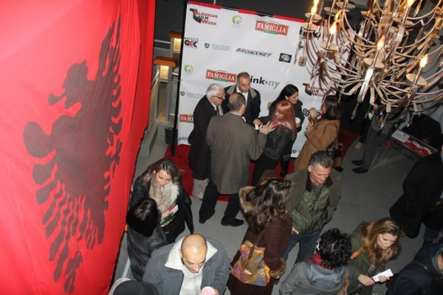(Banner with sponsors and supporters of event and members of Albanian Community)
Activities
The AFW program started with presentation of the latest production of Albanian cinematography.

In addition to movie presentation, open debates with special focus on Albanian cinematography were chaired. Movie producers, directors, actors, scriptwriters and Albanian cinematographs were part of these debates. The foundation, history and current affairs in Albanian cinematography were topic for discussion. The subjects for these debates were very welcomed by Albanian artists in New York, who had the opportunity to present their ideas related to development of Albanian cinematography and its integration in the world.

After the end of Albanian Week, a number of receptions were organised, aiming to bring the Albanian community together with other art loving communities present in this edition.
These receptions were hosted and organised by Producers Club Theatre and “Arte|” Club, that gave more glamour and allure to this event Albanian Film Week in New York.
Some of the media that followed the event

First Edition of Albanian Film Week in New York was followed by many representatives of Albanian and American media:
http://gazetadielli.com/java-e-filmit-shqiptar-ne-new-york/
http://www.bronxnet.org/news/225-albanian-film-screenings-at-bronxnet
http://www.koha.net/?page=1,5,115799
http://prishtinapress.info/100-for-100-albanian-film-week-nov-5-11-nyc/
http://www.albanianevents.com/event_details.php?id=1097

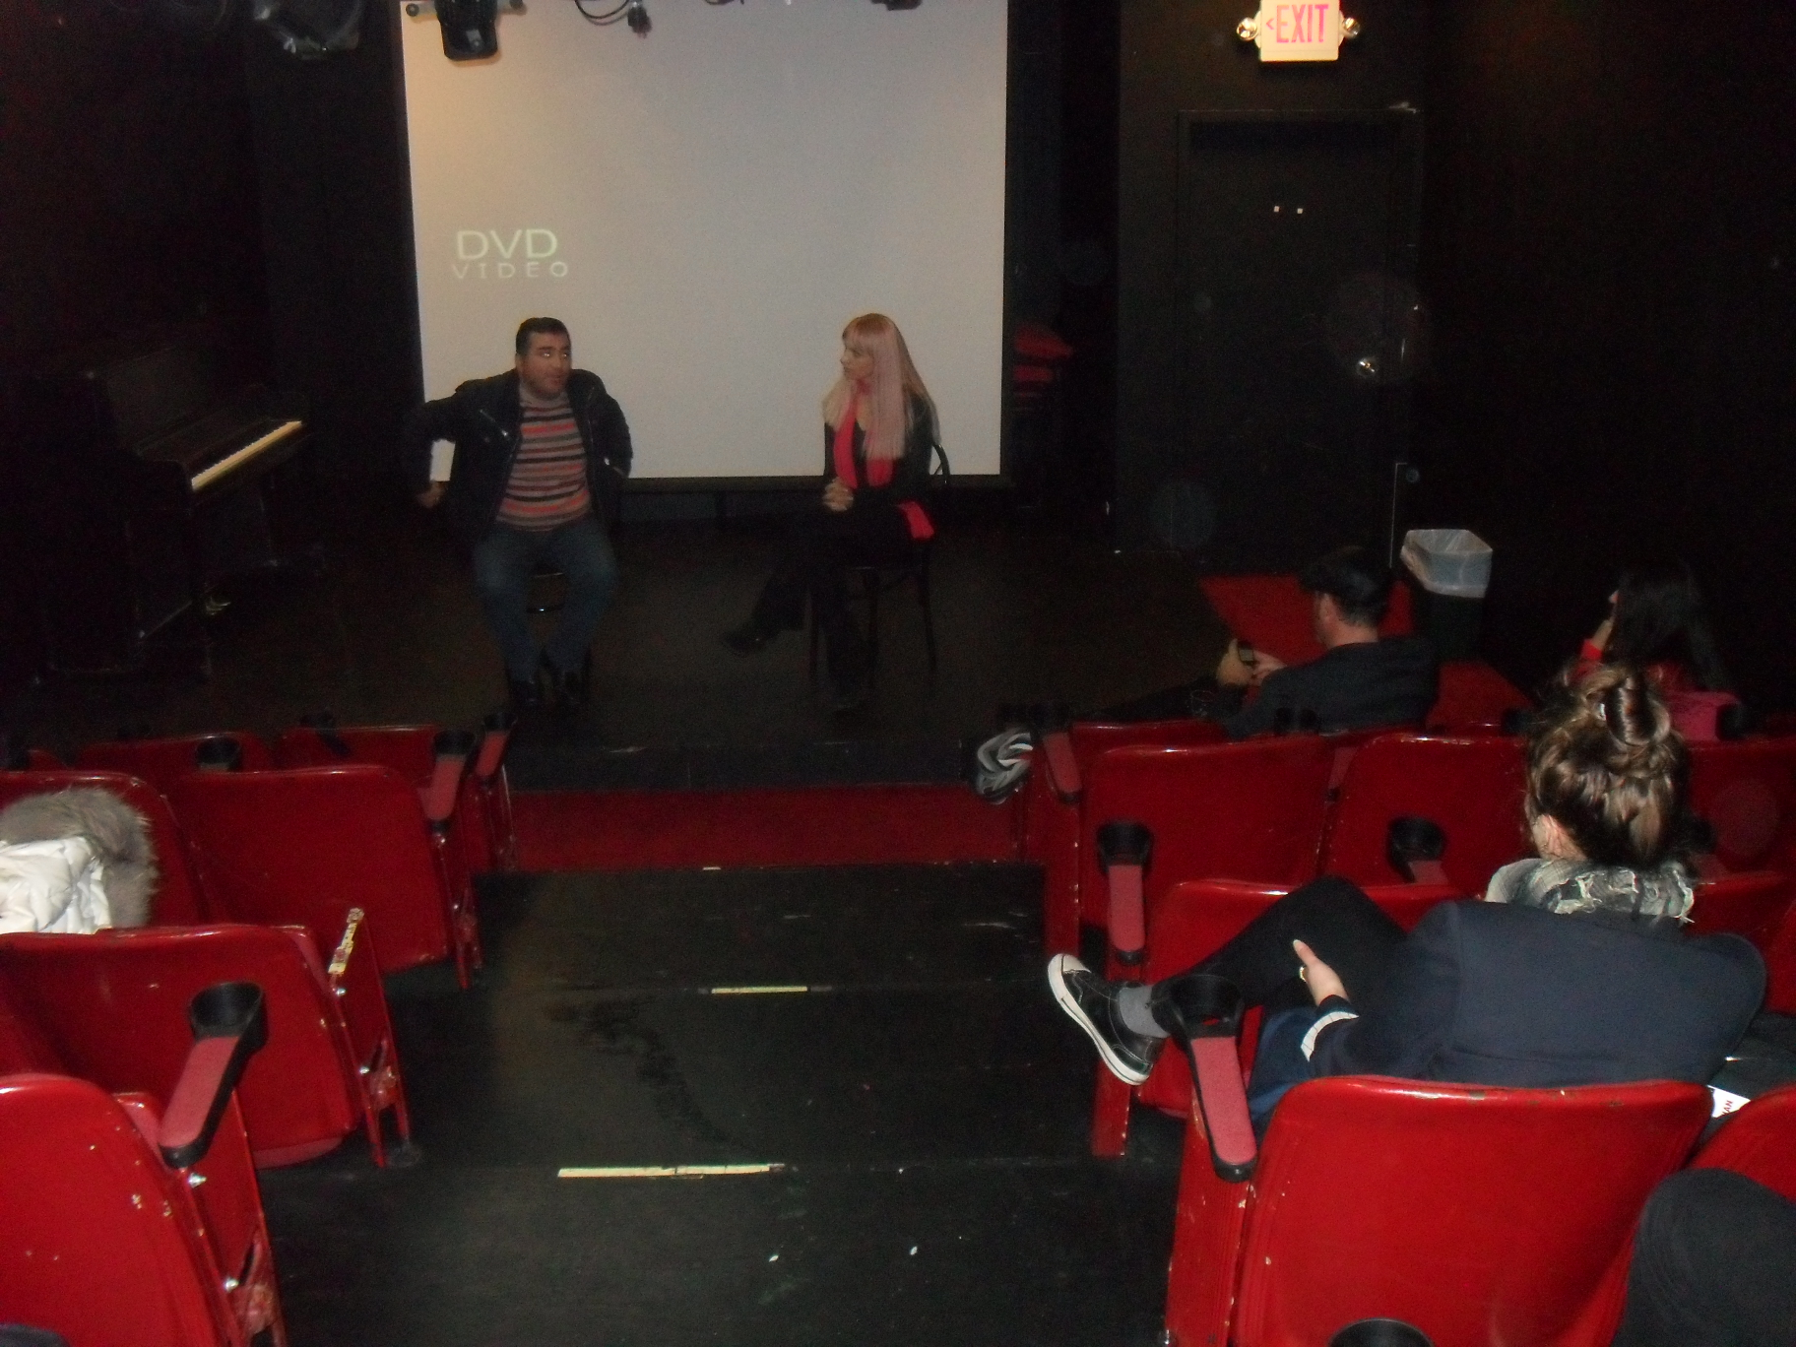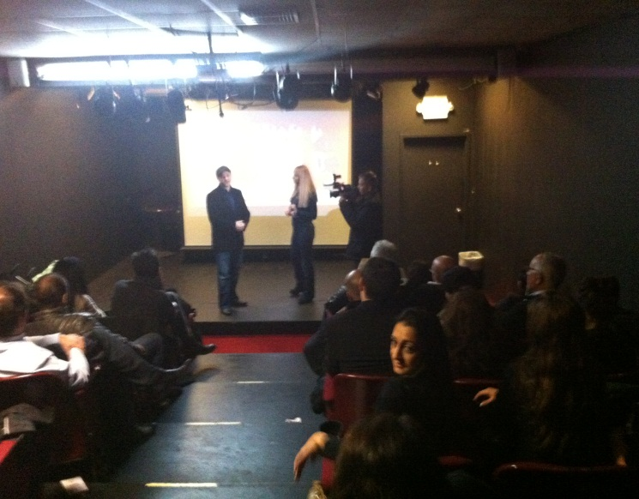Images from debates, arranged during Albanian Film Week in 2012

Collaborators and Sponsors
First edition of Albanian Film Week in New York was organised in cooperation with Nil
Production, Kosovo Embassy in New York, Producers Club Theatres etc. Sponsored by: Pizza Famiglia, LinkNy, Bronxnet, Kosovo Embassy in New York, Municipality of Prishtina, and Ministry of Culture, Sports and Education of Kosovo, Albanian National Center of Cinematography Kosovo Center of Cinematography, Kosova film, Prishtina Group and other productions.
During this movie edition, Albanian movies were presented in three American theatres. The entire Albanian community, as well non- Albanian communities living in New York were given the opportunity to follow the entire program of the Movie Week.
Firs Edition of Albanian Film Week was closed on 11.11.2012 with the 100th movies (100), “Nëntori i dytë”, many members of Albanian Community who welcomed the event wished form this event to continue in the years to come.

ALBANIAN FILM WEEK PROGRAM – First Edition

    - MONDAY/ TRIBECA CINEMA

18:00 - Opening Ceremony.
- Kolona/Beyond. Short. 26 min. Ujkan Hysa.
- Iliriana. Short. 24 min.Ernest Meholli.
- Historia e Futbollit shqiptar/History of Albanian football .Doc.15 min. Besnik Ajazi.

06.11.201 TUESDAY/ PRODUCERS CLUB THEATRE. (358w 44st Fl2 NY)

12:00 - Kati IV/Flor IV.Short. 12 min.Ben Apolloni.
- Leonardi/Leonard. Short. 23 min. Arian Mustafa.
- Nusja /The bride,37 min.Short.Korab Lecaj.
- Muri/Wall, Short. 22 min. Gazmend Nela.
- Për Ata/For them. Short. 24 min.Burim Baftiu.

14:00 - Këpuctari/The shoemaker. Short. 20 min. Artan Korenica.
- Lena & une / Lena & Me .Short. 15 min. Blerta Basholli.
- In memoriam. Short. 26 min.Ilirian Himaj.
- Busulla/The Compass. Short.19 min. Bujar Alimani.
- Sekretet/Secrets. Short.29 min.Esat Fejza.
- Falja/Forgiveness.Short.34 min. Lul Gjoka.
16:00 - Iliriana. Short. 24 min.Ernest Meholli.
- Pertej rruges/ Beyond the road. Short. 21 min. Yll Çitaku.
- Kënaqësitë/Pleasures).Short. 33 min. Edi Qashku.
18:00 - Anatema. Feature film. 1:49 min. Agim Sopi.
20:00 - Mao Ce Dun, Feature film. 1:30 min. Besnik Bisha.
22:00 - Shtëpia/Home. Short. 7 min. Blendi Tare.
- Biri im/My son, Short. 32 min.Engjëll Leka.
- Ëndërra ime/My dream, Short. 29 min. Enea Kita.

07.11.2012/ WEDNESDAY/ PRODUCERS CLUB THEATRE(358Ë 44st Fl2 NY)

12:00 - Kur xhirohej nje film,Feature film. 1:01. Xhanfise Keko.
- Vdekja Solemne/The solemn death) sh. Movie. 35 min. Ilir Kabashi.
- Vetja ime/My ego.Short. 38 min. Lara Hasnjoku.

14:00 - Kaseta e dasmës/The wedding tape. Short. 19 min. Ariel Shabani.
- Teshja/Sneeze.Short. 5 min. Sabri Pajaziti.
- Tri dritare/Three windows. Short. 30 min. Faton Bajraktari.
- Lëkura që djersinë/Sweating skin.Short.14 min.Valjet Rexhepi.
- Shënjtorja/She, the Saint. Short. 35 min. Eno Milkami.
- Knockdown.Short. 17 min.Amir Vitija.

16:00 - Te Bekuarit/The blessed Documentary. 44. min. Vladimir Prifti.
- Rrënja/The Root, Documentary. 35 min. Alush Kamberi & Aco Ristovski.
- 117. Documentary. 20 min. Besim Sahatqia.
- Mbijetesa/Survival.Documentary. 34 min. Dibran Fylli.
- Ikona e Loteve/Icon of tears. Documentary. 31 min. Ilir Kabashi .
20:00 - Nata pa Hënë/Moonless Night. Feature film.1:16 min. Artan Minarolli.
- Lulekuqe mbi mure. Feature film. 1:34 min. Dhimiter Anagnosti
23:00 - Kosova 911. Short. 13 min.Burbuqe Berisha.
- Virgjëresha/Virgo. Short. 35min.Drin Pallaska.
08.11.2012 THURSDAY/ PRODUCERS CLUB THEATRE.(358W 44st Fl2 NY)

12:00 - Kthimi i ushtrisë së vdekur. Feature film.1:43 min. Dhimiter Anagnosti.
- Lindje perëndim lindje/East west east. Feature film. 1:38 h .Gjergj Xhuvani.
- Ketu / Here. Documenatry. 20 min. Emin Halili.
16:00 - Kukumi. Feature film. 2 h. Isa Qosja.
18:00 - Historia e Futbollit shqiptar/History of Albanian football, Doc.15 min. Besnik Ajazi.
- Historia e nje televizori. Short. Fitim Shala.
- Mësuesja ime e pare/ My First Teacher, Short. 27. Shqipe Bukoshi.
- Fjalët/Words, short. 26 min.Bleron Jahaj.
- Hekurishtja/Ironmongery, Short. 20 min. Burim Haliti.
20:00 - Beni ecen vet. Feature film.1:14 min. Xhanfise Keko.
- Mulliri/The mill. Short. 28 min. Ilirijan Himaj.
22:00 – Guna permbi tela. Feature film.1:23.Muharrem Fejzo.
- Gjurme ne kaltersi. Feature film. Saimir Kumbaro.
- Fundi i një gjakmarrjeje, Feature film. Rikard Ljarja.
- Duke kërkuar 5 orëshin, Short.22 min. Xhezair Dafa.
- Arjana, short.17 min. Grigor Stavri.
- Ëndërr e thyer/Broken Deram. Short. 8 min. Lea Kika.
- Hakmarrja, Short. 11 min.Trim Gora.
- Luleshitësi. Short. 13 min. Besa Qefalia.
- Vetëm. Short. 20 min. Xhulieta Vllahu.
- Brenda. Short.14 min.Adhurim Kida.

09.11.2012 FRIDAY/ LEHMAN COLLEGE.(250 Bedford Park Boulevard West)

12:00 - Gjoleka Djali i Abazit/Father and Godfather. Feature film. 1:42. Dhimiter Anagnosti.
- Gomaret e Kufirit/The Border Donkeys, Feature film. 1:37 min. Jeton Ahmetaj.
- Kolona. (Beyond). Short. 26 min. Ujkan Hysa.
- Antena/Antenna, Short. 18 min. Gentian Rexhep Koçi.
- Hekurishtja (Ironmongery) Short. 20 min. Burim Haliti.
- Ketu.Here, Documenatry. 20 min. Emin Halili.

PRODUCERS CLUB THEATRE. (358W 44st Fl2 NY)

18:00 - Dasma e Sakos/ Sacco’s Wedding, Feature film. 1:38min .Vladimir Prifti.
- Amnistia/Amnesty, Feature film. Bujar Alimani.
22:00 - Si te vdiset/ How to die, Feature film . 1:27 min. Miomir Stamenkoviq.
- Deshmitari 1. Short. 7 min. Adhurim Kida.
- Vetëm një rrugë. Short.18 min.Ilir Kabashi&Getoarbe Mulliqi.
- Secila kënge/Each song, Short. 25 min. Alket Kasemi.

10.11.2012/E SHTUNË/SATURDAY/LEHMAN COLLEGE.(250 Bedford Park Boulevard Ëest)

12:00 - Kodi i Jetës. Code of life, Feature film. 1: 51 min. Ekrem Kryeziu.
- Ne dhe Lenini /Lenini and us, Feature film. 1:22min.Saimir Kumbaro.
- Goli Otok, Documentary. 56 min. Mrika Krasniqi.
- Mallkim Gjaku . doc. 54 min. Afet Miftari & Alush Kamberi.

PRODUCERS CLUB THEATRE (358Ë 44st Fl2 NY)

18:00 - Proka. Feature film. 1:35 min. Isa Qosja.
- Falja e gjakut /The forgiveness of blood, Feature film. Joshua Marson & Andamion Murataj.
- Trëndafili i verdhë/ Yellow pink, Short. 30 min.Liri Agolli.
- Lufta/ War, 25 min. Short byFaton Bajraktari.
- UN Kosova. Short. 17 min byBurim Baftiu.
- Bodrumi/ Basement, Short.23 min. Arian Mustafa.
- Koha/The time, Short.20 min.Manjola Prifti.
- Koha modern/Modern time. Short. 29 min.Rron Jusufi.
11.11.2012/E DIEL/SUNDAY/PRODUCERS CLUB THEATRE. (358Ë 44st Fl2 NY)

12:00 –- Amaneti i Nënë Terezës. Documentary. 24 min. Alush Kamberi.
- Krimi/The crime, . Documentary 30 min. Dibran Fylli.
- Sekreti i Akiut/Secret of Aki,. Documentary. 43 min. Merita Çoçoli Sali.
- Lahutari i fundit/Last lute. Documentary. 43 min.Sahit Kokolli.
15:00 - Gjakova 726. Short. 32 min.Blerta Basholli & Artan Korenica.
- Takimi/Meeting, Short.2 min. Festim Rexhepi.
- Arena/Arena, Short. 13 min. Jozefina Luci.
- Diell/Sun. Short. 28. Min. Najada Anagnosti.
- Përtej Ylberit.(Beyond the rainboë). Short. 19 min.Ina Hasku.
- Plaku/ Elder. Short. 16. min. Gojart Fetahaj.
18:00 - Veç kuq/Only red . Short. 20 min. Durim Kryeziu.
- Denis Profeti. Short. 18 min. Ilir Gjocaj.
- Për ters at’çast /Jinx in a Jiffy. Short.17 min. Gentian Rexhep Koçi.
- Neë Born. Short. 3 min. Sabri Pajaziti.
- Si qeni n’ rrush. Short . 28 min. Driton Hajredini & Yll qitaku.
20:00 – Koha e Kometes/Time of the comet. Feature film. 1:43. Fatmin Koçi.
22.00 – Nëntori I dytë. Feature film. 1:23 min.Viktor Gjika.

Albanian Film Week in New York – 2nd Edition

Second Edition of Albanian Film Week in New York was held from the 08th of November through 14th of November 2013. Many Albanian produced movies were presented in this edition; feature movies, short movies and documentaries were brought to the audience during this edition. Cineastes from Kosovo, Albanian, Macedonia, Europe and US became part of this cultural event with their movie productions.

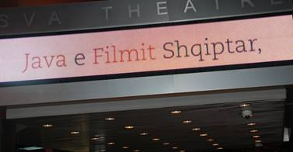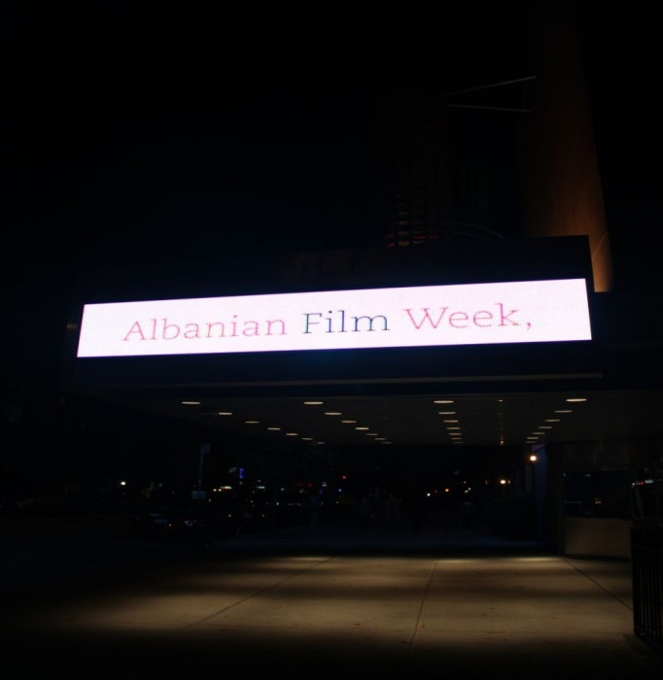

Also, during the seven days of Movie Week; movie producers, directors, actors, screenwriters and Albanian cinematographs were part of the debates dedicated to history of Albanian cinematography and different stages of its development, including the basis of cinematography in Albania and Kosovo as well the movies produced in home studios and private artistic productions.
Presentation of movies of different genres represented an image of Albanian art and culture. The American and Albanian public had the opportunity to know closely the history, culture and socio-political circumstances in all territories the Albanian community lives.

Many distinguished Albanian cineastes living in the United States have supported some debates in the Event. Representatives from American Film studios who are researching on possible topics for major movie productions have attended the debates. Their presence and the opportunity to create contacts with Albanian producers will be an important step and a great chance for cooperation between Albanian and American producers.

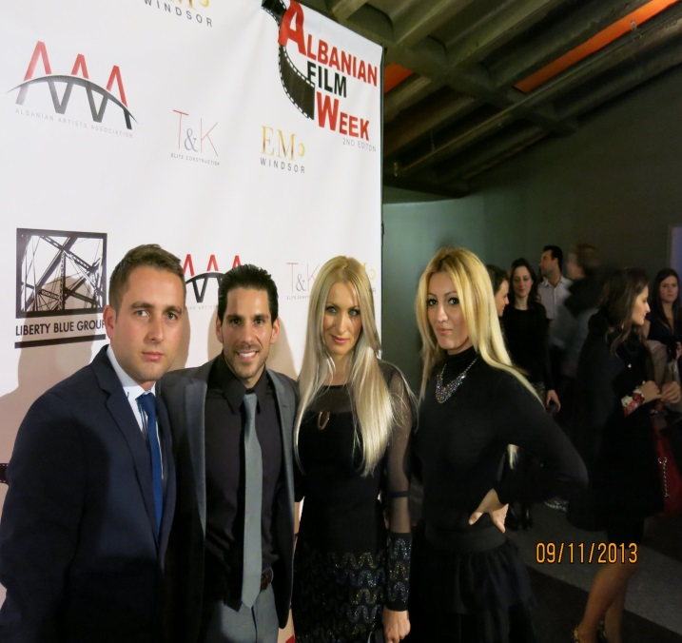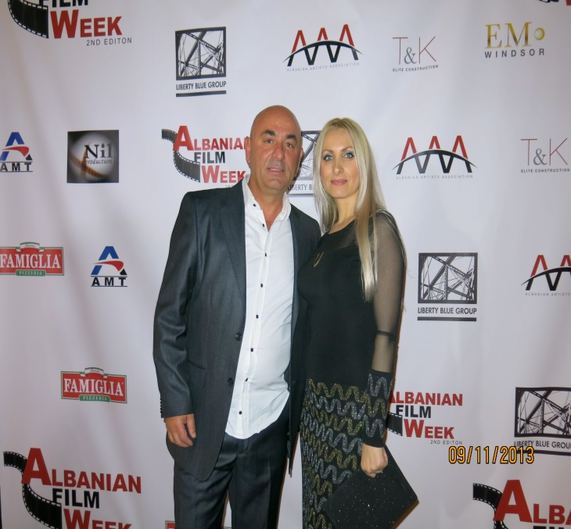
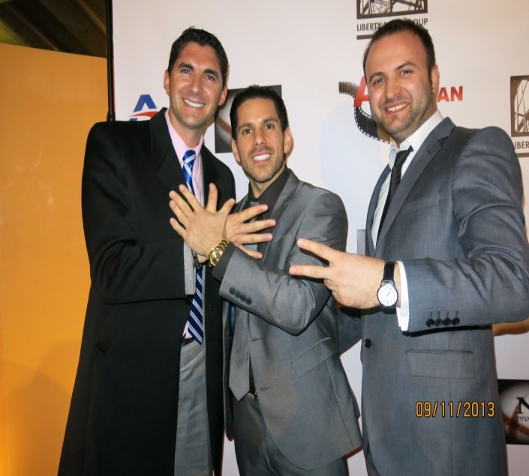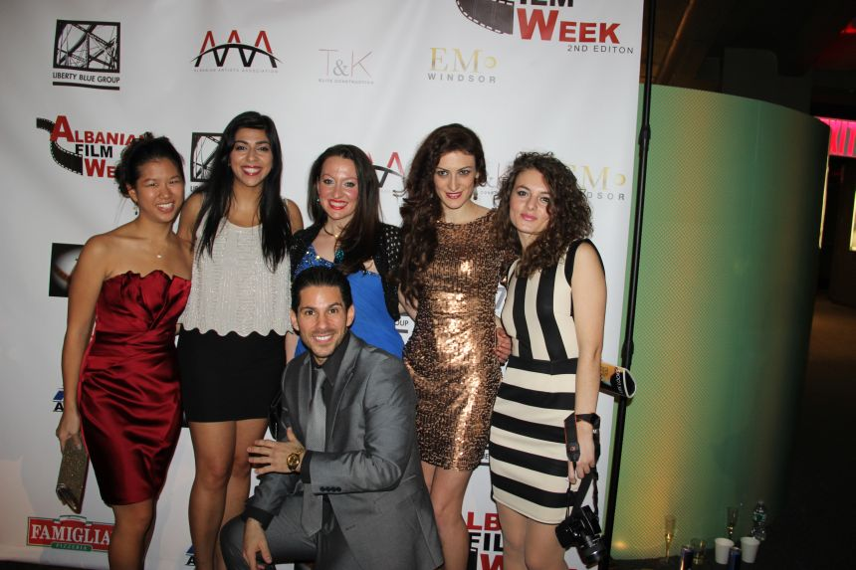

(Actorrs, producers, and organisers of Albanian Film Week 2013)

Albanian Film Week Program –2nd edition

The opening of Albanian film week in New York was made with the movie “Agon” from Robert Budina, Albanian known producer, the movie was welcomed by New Yorker audience.

This movie week edition brought 30 different movies of different Albanian cinematographers to big screen.
Five (5) feature movies, ten (10) short movies were in competition, while ten (10) movies were outside the competition and part of the promotion program.
First Albanian cinematography movies where the Albanian language was used for the very first time were presented in one of the movie week evenings. Various projects that have contributed to building of the history of Albanian cinematography, along with first authors and productions of directors that are no longer with us were presented during the event.
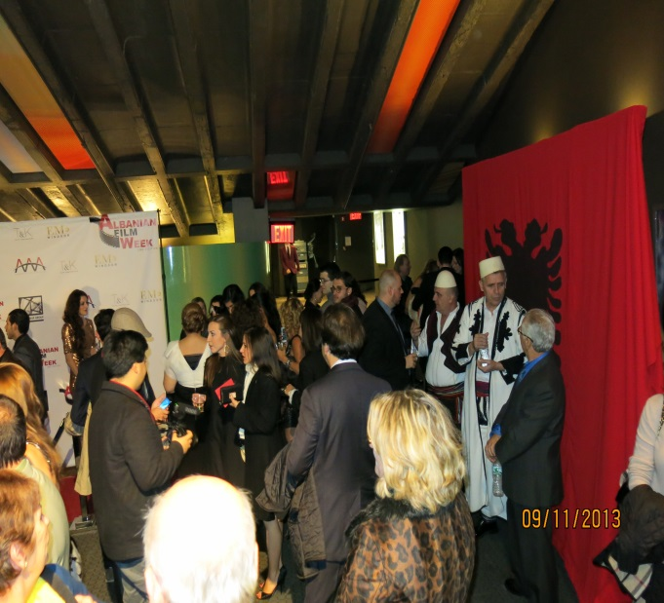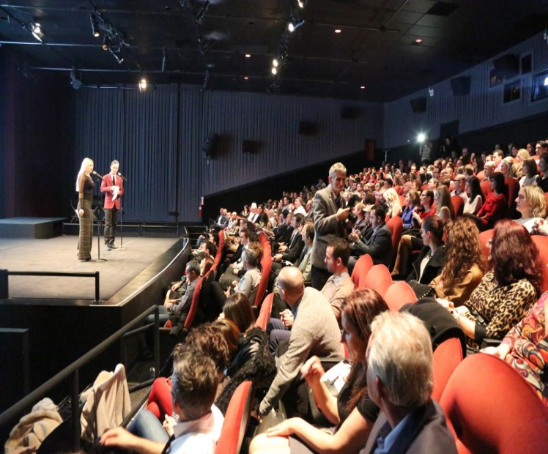

Three best prices were delivered on the closing night to, “E drejta për të dashuruar”,, “Right to Love” by Paul Kurti, feature film, “Rrëfimi i fundit”, by Ibrahim Deari (short movie ), and “ Çmimi i të Qenurit Grua”, from Ilir Kabashi (documentary). The award for live achievement was delivered to Albanian actress in New York, Mrs, Pavlina Mani.

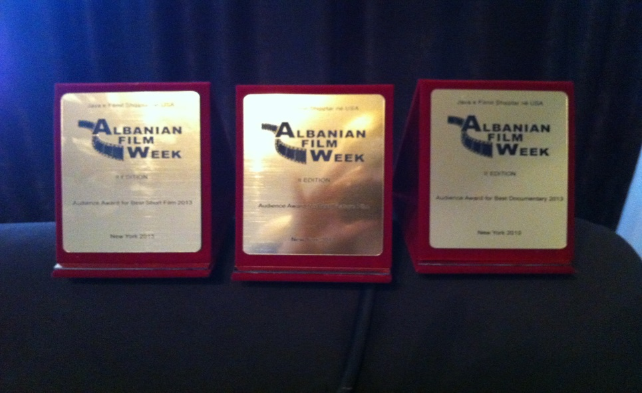

(
(Prices delivered in Movie Week 2013)

ALBANIAN FILM WEEK PROGRAM-2nd Edition 2013

08.11.2013/ FRIDAY/ E PREMTE/ SVA Theatre ( 333 Ëest 23rd Street, New York).

19:00 - Opening Ceremony /Ceremonia e hapjes. Introduction (20 min).
- Sunrise/Agon– Feature film/ F. i gjate – directed by/regjia: Robert Budina.1:46 min. ALB/ENG SUBTITLES. Albania/Shqipëri. (Non-copetition). (20 min Q&A) to follow with the director.

09.11.2013/ SATURDAY /E SHTUNË/PRODUCERS CLUB THEATRE (358Ë 44st Fl2 NY).

18:00 - Last Confession/Rrefimi , fundit, Short/I shkurtër- directed by/regjia: Ibrahim Deari. 14 min. ALB/ENG SUBTITLES. Macedonia/Maqedoni. (Competition).
-The Tailor/Rrobaqepësja, Short/ i shkurtër – directed by/regjia: Arlinda Morina. 35 min. ALB/ENG SUBTITLES, Kosova/Kosovë. (Competition).
-Heshtje -Short/I shkurtër, directed by/regjia: Bekim Guri. 6 min. ALB/ENG SUBTITLES. Kosova/Kosovë, (Competition).
- The Superintendent/ Mbikqyrësi, Short/I shkurtër – Directed by/regjia: Roland Oruqi. 18 min. ENG.SUBTITLES, USA. (Competition).
- Made in America, Short/I shkurtër – directed by/regjia: Orges Bakalli.12 min. ALB/ENG SUBTITLES. USA. (Competition).

20:00 - Agnus Dei – Feature film/ F. i gjatë - directed by/regjia: Agim Sopi. 1:45 min. ALB/ENG /SUBTITLES. Kosova/Kosovë. (Competition). (Q&A) to follow with the director.

10.11.2013/ SUNDAY/ E DIEL/PRODUCERS CLUB THEATRE (358Ë 44st Fl2 NY).

18:00 – Not A Carëash/ S’është Lavazh –Documentary/doc. -directed by/regjia: Gentian Koçi. 50 min. Albania/ Shqipëri. (Competition).
- Between Paradise and Hell/Në Mes të Parajsës dhe Ferrit-Short/i shkurtër – directed by/regjia: Ibrahim Deari. 13 min. ALB/ENG SUBTITLES. Macedonia/Maqedoni. (Competition).
- Dawn/Agonia-Short/I.shkurtër -directed by/regjia: Esat Fejza. 23 min. ALB/ENG SUBTITLES. Kosova/Kosovë. (Competition).
- The man/Burri – Short/I shkurtër – directed by/regjia: Ben Apolloni. 26 min. ALB/ENG SUBTITLES. Kosova/Kosovë. (Competition).

20:00- Pharmakon/Farmakon- directed by/regjia: Joni Shanaj. 2:16min. ALB/ENG SUBTITLES. Albania/Shqipëri. (Competition).

11.11.2013/ MONDAY/ E HËNË/PRODUCERS CLUB THEATRE (358Ë 44st Fl2 NY).

18:00 – Programme – “White & Black“ - Programi “Bardh e Zi”. (Open debate/Debat i hapur. “Albanian Cinematography and Influence in the World”/”Kinematografia Shqiptare dhe Ndikimi i sajë në botë”.

20:00 - The Price a Being a Women /Çmimi i të Qenit Grua – Documentary/doc.-Directed by/Regjia: Ilir Kabashi. 53 min. ALB/ENG SUBTITLES. Kosova/Kosovë. (Competition).
- Postcard From London/Kartolinë nga Londra –Documentary/doc - directed by/regjia: Naser Shillova. 36 min. ALB/SHQIP. England/Angli. Competition).

12.11.2013/ TUESDAY/ E MARTE/ PRODUCERS CLUB THEATRE (358Ë 44st Fl2 NY).

18:00 – Out of Sight/Larg Syrit - Documentary/doc.-Directed by/regjia:Paul Kurti – 15 min. ALB/ENG SUBTITLES. Albania/Shqipëri. (Competition).
-Jona - Short/I shkurtër – directed by/regjia:Eneida Koreshi. 15 min. ALB/ENG SUBTITLES. Albania/Shqipëri. (Competition).
- Tie/Kravata-Short/I. shkurtër – directed by/regjia: Ekrem Xani. 24 min. ALB/ENG SUBTITLES. Kosova/Kosovë. (Competition).
- The First Tunnel /Tuneli i Pare/ Short/I shkurtër – directed by/regjia: Fatos Hoti. 10 min. ALB/ENG SUBTITLES. England/Kosovë. (Competition).

20:00 - Sunrise/Agon– Feature film/ F. i gjatë – directed by/regjia: Robert Budina.1:46 min. ALB/ENG SUBTITLES. Albania/Shqipëri. (Non-competition).-reprize.

13.11.2013/ ËEDNESDAY/E MËRKURE/ PRODUCERS CLUB THEATRE (358Ë 44st Fl2 NY).

18:00 – Programe – “White & Black“ - Programi “Bardh e Zi”.

20:00 - Lindja Nuk Pret – Documentary/doc –directed by/regjia: Parta Kelmendi. 20 min. ALB/ENG SUBTITLES. Kosova/Kosovë. (Competition).
- E vërteta Mbi Tragjedinë e Urës së Lluzhanit – Documentary/doc. – directed by/regjia: BDEF. 20 min. ALB/SHQIP. Kosova/Kosovë. (Non-competition).
-The Land of Kelmend / Toka e Kelmendit – Documentary/Doc. – directed by M. Krasniqi. 25 min. ALB/ENG SUBTITLES. Kosova/Kosovë. (Non-competition).

14.11.2013/ THURSDAY/E ENJTE/ PRODUCERS CLUB THEATRE (358Ë 44st Fl2 NY).

18:00 – God’s Land/Toka e Zotit -Short/I shkurtër – directed by/regjia: Mentor Spahiu. 18 min. ALB/ENG SUBTITLES. Kosova/Kosovë. (Competition).
- Wheel/Rrota – Short/I shkurtër – directed by/regjia:Fisnik Muji. 32 min. ALB/ENG SUBTITLES. Kosova/Kosovë. (Competition).
- The Blood Money/Para te Pergjakura - Short/I shkurtër - directed by/regjia: Erman Memedi. 9 min. ALB/ENG SUBTITLES. Macedonia/Maqedoni. (Competition).

20:00 - Right to Love/ E Drejta per te Dashuruar- Feature film/ F. i gjatë – directed by/regjia: Paul Kurti/ 1:30 min. ALB/ENG SUBTITLES. USA.(Competition).Q&A.

Some of the media houses that followed the 2nd Edition of Albanian Film Week.

http://kosovodiaspora.org/2013/11/05/albanian-film-week-continuing-success-in-new-york/
http://gazetadielli.com/java-e-filmit-shqiptar-ne-new-york/
http://www.bronxnet.org/news/225-albanian-film-screenings-at-bronxnet
http://www.koha.net/?page=1,5,115799
http://prishtinapress.info/100-for-100-albanian-film-week-nov-5-11-nyc/
http://www.albanianevents.com/event_details.php?id=1097
http://www.devolli.net/new-yorku-pret-festivalin-e-filmit-shqiptar-albanian-film-week.html
http://www.shqiptarja.com/kultura/2730/nju-jork-30-filma-shqiptare-ne-albanian-week-film-festival-184515.html
http://issuu.com/albaniac/docs/albaniac_revista_finale_6ee62995ccd3c0 —
http://nyelitemagazine.com/prominent-filmmaker-amina-zhaman-attends-yaff-festival-in-new-york/
https://www.facebook.com/notes/kozeta-zylo/n%C3%AB-teatrin-sva-n%C3%AB-manhattan-u-zhvillua-ceremonia-e-hapjes-s%C3%AB-edicionit-t%C3%AB-dyt%C3%AB-t/667371506616249
https://www.facebook.com/notes/kozeta-zylo/n%C3%AB-teatrin-sva-n%C3%AB-manhattan-u-zhvillua-ceremonia-e-hapjes-s%C3%AB-edicionit-t%C3%AB-dyt%C3%AB-t/667371506616249
http://www.koha.net/?page=1%2C5%2C163809
http://tribunashqiptare.net/?p=18787
http://www.ekonomia-ks.com/?page=1%2C25%2C359624
http://prizrenpress.com/kulture/york-pret-festivalin-albanian-film-week/

Promo AFW 2013
http://www.youtube.com/watch?v=zy59CteN5TM&feature=share

Albanian Film Week 2013 was supported from Kosovo Ministry of Diaspora, Ministry of Culture, Kosovo Embassy in New York, etc. As well the sponsored: Liberty Group, Pizza Famiglia, T&K, AMT, Emo, etj.

The movie projects during the Albanian Film Week 2013 were presented in two American theatres, SVA Theatre (333 west 23rd street, NY) and Producers Club Theatre (358 west 44st NYC 10036).

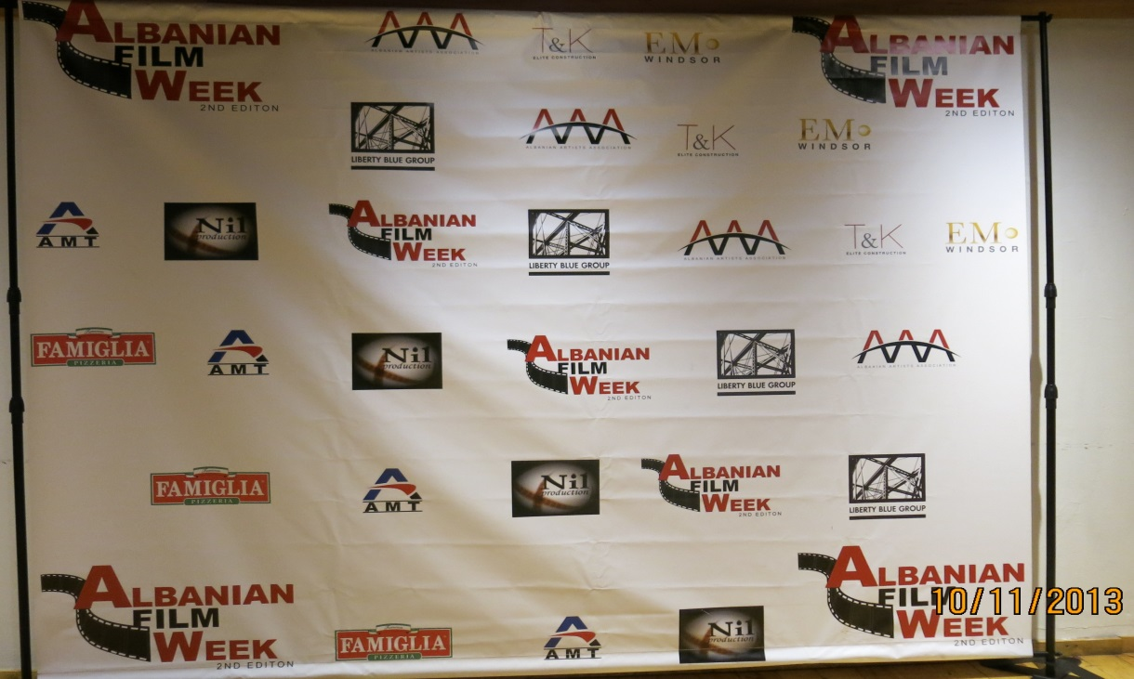
(Banner from the Event in 2013)

Albanian Film Week in New York -3rd Edition

Third edition of Albanian Film Week will be coming to you this November, with a competition program, with 30 movies that will present the extraordinary work during of Albanian producers worldwide during 2012-2013. Also foreign movie productions that present historical events related to Albanians will be part of this edition.
Three movie genres that will be presented during the event are, feature movies, short movies and documentaries. Therefore, Albanian cinema will be relived in the screens of capital of the world, the city of New York with series of movies with different subjects of Albanian history and culture.
An artistic panel composed of distinguished Albanian cineaste from Kosovo, Albanian, Macedonia, and the USA such as Robert Budina, Vlora Qosja, Ilir Kabashi dhe Ben Fejza, has been set up.

AFW Mission

One of the most powerful ways to share and gain knowledge is the sharing of the universal language of movie art. Whether you find it in theatre, TV, DVDs or on internet, the movie entertains, educates, enlightens, inspires and influences the way we act and understand the world.

By presenting movie projects in the US, we aim to present historical and cultural values of the Albanian nation and its journey in cinematography.
The mission of Albanian Film Week is to create and develop a culture where the Albanian movie is known and liked by the foreign audience, with a special aim of offering and creating new perspective for Albanian movie.
AFW Vision

To establish an Albanian Film Week in the United States, that would serve as a bridge between the European and American Film in creating alliances and collaborations in the art of cinematography.

New York Albanian Film Week (AFW)
Mrika Krasniqi, Founder and Executive Director
www.albanianfilmweek.net
albanianfilmweek@gmail.com
+1(347)2377882 (USA)
+377 44 347318 (Europe)

